17th April 2026
Creating ASP.NET Web App
Deploying App Using Visual Studio & Kudu
Run App in Staged Environments using Deployment Slots
Working with Configurations
Accessing Configuration using ASP.NET Application
Host API with CORS
Creating and Using Web Jobs
Ways to Authenticate App Services in Azure Azure Function App
Overview of Serverless Computing
Benefits of Serverless Computing
Serverless Comparison
Hosting Plan

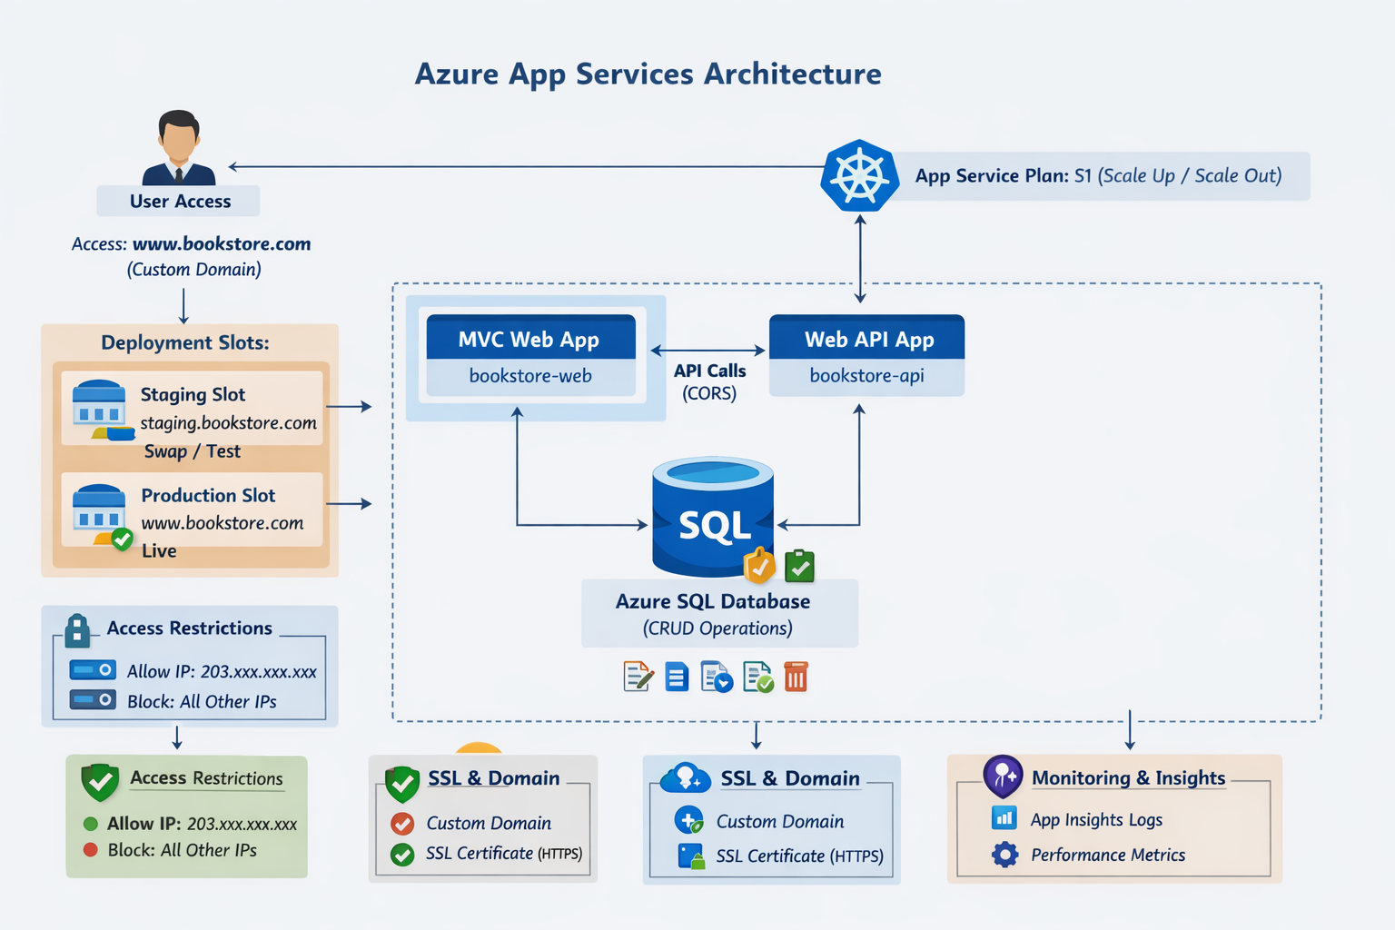

PART 1: ASP.NET Web App + Azure App Service (Step-by-Step Notes)

1. Creating ASP.NET Web App

Using Visual Studio
- Open Visual Studio
- Click Create New Project
- Select:
  - ASP.NET Core Web App (MVC)
- Configure:
  - Project Name: MyWebApp
  - Framework: .NET 8 (or latest)
- Click Create

Project Structure:
- Controllers → logic
- Models → data
- Views → UI
- appsettings.json → configuration

2. Deploying App Using Visual Studio & Kudu

Deploy using Visual Studio
- Right-click project → Publish
- Select:
  - Azure → App Service
- Sign in → Select subscription
- Create new App Service:
  - Name: mywebapp-kk
  - Runtime: .NET
- Click Publish

Verify using Kudu
Kudu = Advanced management tool
Open:
https://<your-app-name>.scm.azurewebsites.net

What you can do:
- Browse files → site/wwwroot
- Debug logs
- Run commands (PowerShell / CMD)

3. Run App in Staged Environments (Deployment Slots)

Why?
Avoid downtime → Test before production

Create Slot
- Go to Azure Portal
- Open App Service
- Click Deployment Slots
- Add Slot:
  - Name: staging
  - Clone settings from production

Deploy to Slot
- In Visual Studio → Publish → Select staging

Swap Slots
- Click Swap
- Source: staging
- Target: production
Result: Zero downtime deployment

4. Working with Configurations

Types:
- appsettings.json
- Environment Variables
- Azure App Settings

Add Configuration in Azure
- Go to App Service
- Click Configuration
- Add:
  - Key: ConnectionStrings__DefaultConnection
  - Value: your DB connection

5. Accessing Configuration in ASP.NET

In appsettings.json
{
"ConnectionStrings": {
"DefaultConnection": "your_connection"
}
}

In Program.cs
var builder = WebApplication.CreateBuilder(args);

var connectionString = builder.Configuration.GetConnectionString("DefaultConnection");

In Controller
private readonly IConfiguration _config;

public HomeController(IConfiguration config)
{
_config = config;
}

public IActionResult Index()
{
var value = _config["MyKey"];
return View();
}

6. Host API with CORS

Why?
Allow frontend (React/MVC) to call API

Enable CORS in Web API
builder.Services.AddCors(options =>
{
options.AddPolicy("AllowAll",
policy => policy.AllowAnyOrigin()
.AllowAnyMethod()
.AllowAnyHeader());
});

Use Middleware
app.UseCors("AllowAll");

7. Creating and Using WebJobs

What is WebJob?
Background task inside App Service

Example Use Cases:
- Email sending
- Data processing
- Scheduled jobs

Create WebJob
- Create Console App
- Add code:
Console.WriteLine("WebJob Running...");
- Publish → zip file

Upload WebJob
- Go to App Service
- Click WebJobs
- Add:
  - Type: Triggered / Continuous
  - Upload zip

PART 2: Azure Function App (Serverless)

1. Overview of Serverless Computing
No server management
Azure manages:
- Scaling
- Infrastructure
- Runtime

2. Benefits of Serverless
- Pay only for execution
- Auto scaling
- Faster development
- No infrastructure maintenance

3. Serverless Comparison
Feature | Azure Functions | App Service
Server Management | ❌ | ✔
Scaling | Auto | Manual/Auto
Billing | Per execution | Fixed
Use Case | Event-based | Web apps

4. Hosting Plans (Azure Functions)

Types:
- Consumption Plan
  - Pay per execution
  - Auto scale
- Premium Plan
  - Pre-warmed instances
  - No cold start
- Dedicated Plan
  - Same as App Service

PART 3: Authentication in Azure App Services

Ways to Authenticate:

1. Built-in Authentication (Easy Auth)
- Azure handles login
- Supports:
  - Microsoft
  - Google
  - Facebook

Steps:
- Go to App Service
- Click Authentication
- Add Identity Provider
- Configure

PART 4: REAL-WORLD CASE STUDY (Full Practice)

Case Study: "SmartRetail Web Platform"

Problem
A retail company wants:
- Web App (Admin Panel)
- API Backend
- Background Jobs
- Secure Authentication
- Zero downtime deployment

Architecture
User → MVC Web App → Web API → Azure SQL DB
↓
WebJobs
↓
Azure Functions

Implementation Steps

STEP 1: Create Projects
- MVC Web App (Frontend)
- Web API (Backend)
- Console App (WebJob)

STEP 2: Database
- Azure SQL Database
- Tables:
  - Products
  - Orders

STEP 3: API Development
- CRUD using EF Core
- Enable CORS

STEP 4: Deploy API
- Azure App Service

STEP 5: Deploy MVC App
- Connect to API

STEP 6: Add Configuration
- Store connection string in Azure

STEP 7: Create Deployment Slot
- staging → test
- production → live

STEP 8: Add WebJob
Example:
- Send daily sales report

STEP 9: Add Azure Function
Trigger:
- Timer trigger → every day

STEP 10: Enable Authentication
- Azure AD login

Security Features
- Role-based access
- Token-based API (JWT)

Real-Time Flow
- User logs in
- MVC calls API
- API accesses DB
- WebJob processes background tasks
- Azure Function runs scheduled jobs
- Deployment via staging slot

FINAL PRACTICE RESULT
After completing this:
You know real Azure deployment
You can build production apps
You understand DevOps flow
You can answer interviews confidently

